**Arduino Robot Arm** **Documentation**

**Introduction**

My project is a robot arm controlled by 5 servo motors SG-90. It uses a Bluetooth module for receiving commands. It can also be controlled by the Serial Monitor on the computer that is powering the arm.

**Project Overview**

The project consists of:

* Arduino Board: The Arduino board acts as the brains of the system, controlling the servomotors and processing sensor inputs.
* Five Servo Motors: The motors are responsible for the movement of the arm. There is one base motor for the rotation of the arm, three for the joints and one for the claw.
* Bluetooth module: The module allows for wireless connection between a mobile device and the Arduino.

**Hardware Requirements**

For the robot arm the following materials where used:

* Arduino board
* Five servomotors – 4 SG-90 (180°) and 1 SG-90 (360°)
* Breadboard
* Jumper wires
* Power supply – Arduino cable
* Bluetooth module HC-06

The parts for the project were printed.

**Software Requirements**

To program the Arduino board for the robot arm were used:

* Arduino IDE
* Servo library (included in Arduino IDE)

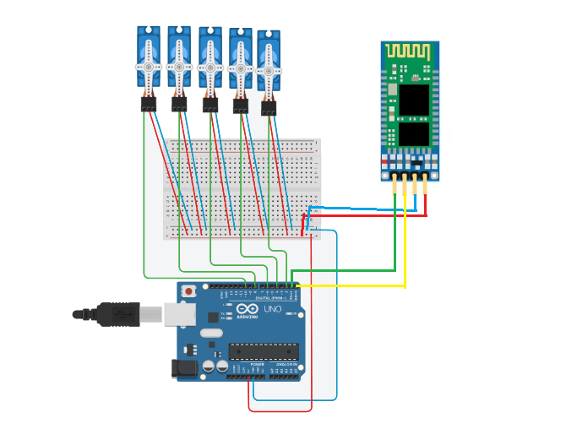**Circuit Diagram**

**Code Explanation**

* The code uses the Servo library to control five motors. In the setup each of the motors is set in a default position. The base servo can rotate at 360° and is controlled differently then the others. If the in the servo is written 90 the motor will stay still. If it’s written 0 it would rotate at full speed in the right direction. The same is true when writing 180 but the motor will rotate left. The closer the number is to 90, the slower the speed of the rotation is.
* The Serial Monitor is called. It is used for telling the board which motor and at what angle to turn.
* In the loop method every time something is written in the Serial Monitor a switch case is called. The first letter of the string is for the motor (‘b’ for base, ‘1, ’2’, ’3’ for the 3 joints and ‘c’ for the claw) and the rest is parameters. They are separated by a space.
* The base has a separate method. In the parameters the first letter is the direction (‘r’ or ‘l’) and the second part is the duration of the rotation (the speed can’t be altered). They are both separated by a space.
* The rest of the motors work in an identical way. In the parameters there is only the number for the angel of the motors.
* There is no code for the Bluetooth module. It is connected to pins 1 and 0 (RXD to 1 and TXD to 0). The default speed for the module is 9600 – the same for the Serial Monitor.

**Problems During Development**

* I didn’t know that the in base motor by directly writhing an angle it would start rotating without stopping.
* Some of the motors had to be replaced because of getting stuck and not being able to rotate without outside interference.
* The code not being able to be uploaded while the Bluetooth module is connected to the board.

**Future Improvements**

Possible future improvements for this project could include:

* Adding a battery to the Arduino.
* Adding a way to control the speed of the arm’s movements.
* 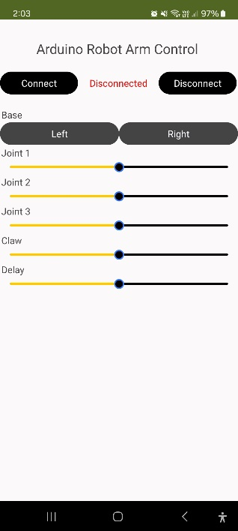Making an app for the arm instead of writing the commands by hand. I tried to create the app in MIT App Inventor:
* Creating a glove with sensors and another Bluetooth module. Controlling the robot arm with hand gestures.

**Contact Information**

My team consists of:

**Kaloyan Petrov** – [kokogpetrov@gmail.com](mailto:kokogpetrov@gmail.com)